Name: MAHORO Raphaela

ID: 24073

COURSE: SOFTWARE MODELING

**UNIVERSITY CLASS DIAGRAM**

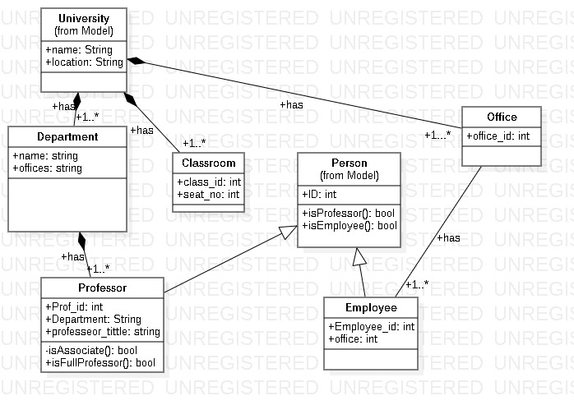

**MOVIE-SHOP CLASS DIAGRAM**

